**4.1 Cognition\***

Information Processing Model

* States that the brain encodes, stores, and retrieves information much like a computer
* Four key pillars:
  + Thinking requires sensation, encoding, and storage of stimuli
  + Stimuli must be analyzed by the brain (rather than responded to automatically) to be useful in decision-making
  + Decisions made in one situation can be extrapolated and adjusted to help solve new problems (also called situational modification)
  + Problem solving is dependent not only on the person’s cognitive level, but also on the context and complexity of the problem

Cognitive Development

* The ability to think abstractly develops over the life span
* **Piaget’s stages of cognitive development**
  1. **Sensorimotor (birth - 2 years old)**: focuses on manipulating the environment to meet physical needs
     + **Primary circular reaction**: repetition of a body movement that naturally occurred by chance e.g. suck on thumb because it is soothing
     + **Secondary circular reaction**: manipulation is focused on something outside the body e.g. keep throwing toys… until parent picks up
     + Child **lacks object permanence** (marks beginning representational thought), which is the understanding that objects continue to exist even when out of view → that is why child finds “peek-a-boo” amusing
  2. **Preoperational (2-7 years old)**: characterized by
     + Symbolic thinking: ability to pretend, play, make-believe, and have an imagination
     + **Egocentrism**: inability to imagine what another person may think or feel
     + **Centration**: tendency to focus on only one aspect of the phenomenon, or **inability to understand the concept of conservation** i.e. cannot see that 2 half-sized pizzas = 1 full-sized pizza
  3. **Concrete Operational (7-11 years old)**: focuses on
     + **Understanding the feelings of others**
     + Manipulating physical (concrete) objects logically
     + NO abstract thinking yet
  4. **Formal Operational (11 years old onwards)**: ability to think logically about **abstract ideas**
* Affected by culture
* Fluid intelligence (problem solving) and crystallized intelligence (learned skills and knowledge)

Heredity, Environment, and Biologic Factors

* Biological factors that affect cognition include organic brain disorders, genetic and chromosomal conditions, metabolic derangements, and drug use
* Delirium = rapid fluctuation in cognitive function that is reversible and caused by (non-psychological) causes

**4.2 Problem Solving and Decision-Making\***

* A **mental set** is a pattern of approach for a given problem. An inappropriate mental set may negatively impact problem solving
* **Functional fixedness** is the tendency to use objects only in the way they are normally utilized, which may create barriers to problem solving

Types of Problem Solving

1. Trial-and-error
2. Algorithms
3. Deductive reasoning (top-down)
4. Inductive reasoning (bottom-up)

Heuristics, Biases, Intuition, and Emotion

* May assist with decision making
* But may also lead to erroneous or problematic decisions

1. Heuristics: Shortcuts or rules of thumb
   1. Availability heuristics: how easily similar instances can be imagined
   2. Representativeness heuristics: how much a particular item or situation fits a given prototype or stereotype
2. Bias and Overconfidence
   1. **Confirmation bias: the tendency to focus on info that fits an individual’s beliefs, while rejecting info that goes against them** → overconfidence
      1. Can involve biases in the search for evidence and in the interpretation of evidence
      2. Found to be stronger for emotionally charged topics
   2. **Belief perseverance (despite clear evidence to the contrary)**
3. Intuition: ability to act on perceptions that may not be supported by available evidence
   1. Recognition-primed decision model (based on experience)
4. Emotion: subjective experience of a person in a certain situation

Intellectual Functioning

1. Multiple intelligences
   1. Linguistic, logical-mathematical, musical, visual-spatial, bodily-kinesthetic, interpersonal, and intrapersonal
2. Variations in Intellectual Ability
   1. Stanford-Binet IQ test

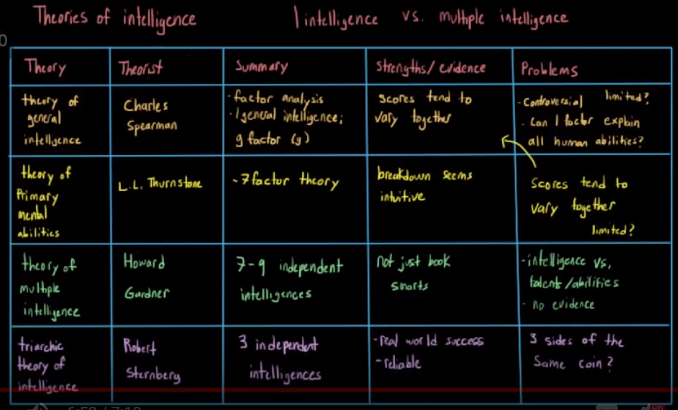

**4.3 Consciousness**

States of Consciousness

* Alertness, Sleep, Dreaming, Altered states of consciousness

Alertness

* A state of consciousness in which we are awake and able to think
* **Beta** (high freq, concentrating on a task)and **alpha** waves (somewhat slower, with eyes closed) predominate on **electroencephalography** (EEG)

Sleep

|  |  |  |
| --- | --- | --- |
| **Stage** | **EEG waves** | **Features** |
| **Awake** | Alpha and beta | Able to perceive, process, access information, and express that information verbally |
| **Stage 1** | Theta | Light sleep and dozing |
| **Stage 2** | Sleep spindles and K complexes |
| **Stage 3** | Delta | Slow-wave sleep; dreams; declarative memory consolidation; sleep disorders occur in this stage |
| **Stage 4** |
| **REM** | Mostly beta | Appears awake physiologically; dreams; procedural memory consolidation; body is paralyzed |

(Stages 1 - 4 are all part of NREM sleep)

* Night: Decreasing light → release of melatonin (in the pineal gland) → sleepiness
* Morning: Increasing light → CRF (from hypothalamus) → ACTH (from anterior pituitary) → cortisol release → wakefulness
* Dreaming
  + 75% of dreaming happens during REM, which are more vivid and longer than those experienced during NREM
* Sleep disorders
  + Dyssomina: disorders that make it difficult to sleep, stay asleep, or avoid sleep
    - Insomnia: difficulty falling asleep or staying asleep
    - Narcolepsy: lack of voluntary control over the onset of sleep
    - Sleep apnea: inability to breathe during sleep
    - Sleep deprivation
  + Parasomnia: abnormal movements or behaviours during sleep
    - Night terrors
    - Sleepwalking (somnambulism)

Hypnosis

* A state of consciousness in which individuals appear to be in control of their normal faculties but are in a **highly suggestible** state (meaning a hypnotized person easily succumbs to the suggestion of others)
* Used for pain control, psychological therapy, memory enhancement, weight loss, and smoking cessation

Meditation

* Involves a quieting of the mind → relief of anxiety
* On EEG, it resembles Stage 1 sleep with theta and slow alpha waves

**4.4 Consciousness-Altering Drugs\***

Depressants

* Reduce nervous system activity → sense of relaxation and reduced anxiety
* Promote or mimic **GABA** activity in the brain → hyperpolarization (receptor is a chloride channel)
* E.g. alcohol, barbiturates, benzodiazepines

Stimulants

* Cause an increase in arousal in the nervous system
* Increases the frequency of action potentials (by different mechanisms)
  + Increases **dopamine**, norepinephrine and serotonin at the synaptic cleft
* E.g. amphetamines, cocaine, ecstasy

Opiates and Opioids

* Naturally occurring forms, opiates e.g. morphine and codeine
* Semisynthetic derivatives, opioids e.g. oxycodone, hydrocodone, and heroin (metabolized to morphine once ingested)
  + Bind to opioid receptors in the PNS and CNS → decreased reaction to pain and sense of euphoria (similar effect to endorphine)
  + Overdose can cause death by respiratory suppression → brain stops sending signals to breathe

Hallucinogens

* Cause distortions of reality and fantasy, enhancement of sensory experiences, and introspection
* E.g. LSD

Marijuana

* Has depressant, stimulant, and hallucinogenic effects
* Active ingredient is tetrahydrocannabinol (THC)

Drug Addiction

* Mediated by the **mesolimbic pathway**, which includes the nucleus accumbens, medial forebrain bundle, and ventral tegmental area
* Dopamine is the main neurotransmitter in this pathway

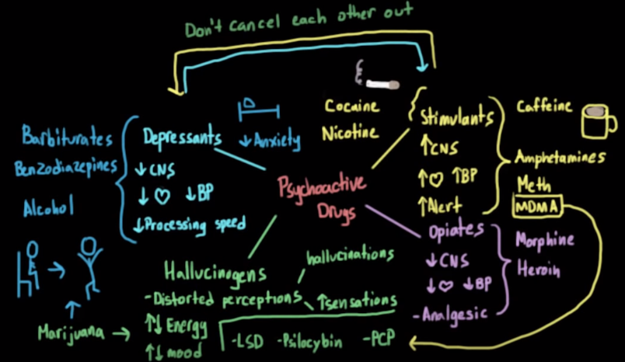

**4.5 Attention**

Selective Attention

* Filter that allows one to pay attention to a particular stimulus while determining if additional stimuli in the background require attention

Divided Attention

* Uses **automatic processing** to pay attention to multiple activities at one time

Shadowing

* A language learning technique in which subjects repeat speech immediately after hearing it
* To test for selective attention, shadowing is often used with dichotic listening task: pay attention to everything to the right ear, and ignore everything that is heard using your left ear → repeat what you hear on the right ear

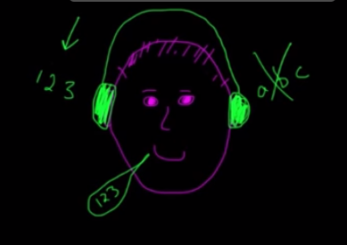

Theories of Selective Attention

1. Broadbent’s Early Selection Theory (Filter → Process)
   1. Problem: If you completely filter out the unattended information before it gets assigned meaning, then you should not be able to identify your own name when it is spoken in an unattended ear (e.g. cocktail party effect: hearing your own name even if you have not been paying attention to the conversation)

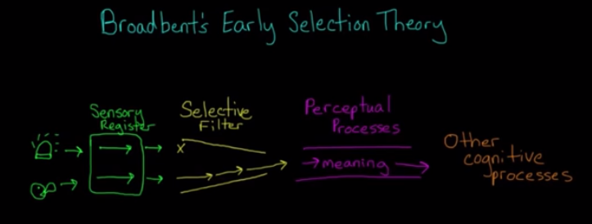

1. Deutsch and Deutsh’s Late Selection Theory (Process → Filter)
   1. Problem: Given the limited resource of attention, and the fact that we know our brain is super efficient, it seems wasteful to spend all that effort assigning meaning to stuff you won’t ever need

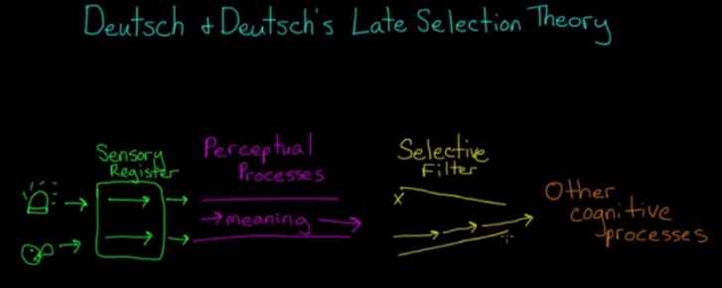

1. Treismon’s Attenuation Theory (Attenuate → Process)

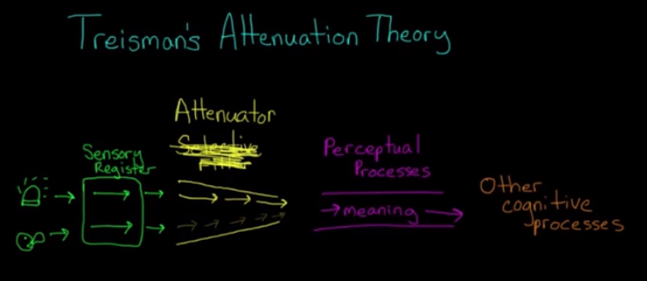

**4.6 Language\***

Components of Language

1. Phonology
   1. Actual sound of language
2. Morphology
   1. Structure of words
   2. E.g. redesigned = re (do again) + design (verb root) + ed (past tense)
3. Semantics
   1. Association of meaning with a word
   2. Young children may categorize all women as mummy
4. Syntax
   1. How words are put together to form sentences
   2. E.g. Nathan has only three pieces of candy IS NOT Only Nathan has three pieces of candy
5. Pragmatics
   1. Dependence of language on context and preexisting knowledge
   2. E.g. Our words are more polite towards strangers, but more casual with friends

Language Development (for children)

1. Nativist (biological) theory
   1. Explains language acquisition as being innate and controlled by the **language acquisition device (LAD)**: a theoretical pathway in the brain that allows infants to process and absorb language rules
   2. **Critical period** (between 2 years old and puberty) → if no language exposure occurs during this time, later training is largely ineffective
   3. **Sensitive period** (before the onset of puberty) → environmental input has maximal effect on the development of an ability
2. Learning (behaviourist) theory
   1. Explains language acquisition as being controlled by **operant conditioning** and reinforcement by parents and caregivers
3. Social interactionist theory
   1. Theorists e.g. **Vgotsky** believe that biological and social factors have to interact in order for children to learn language
   2. Explains **language acquisition as being caused by a motivation to communicate and interact with others** e.g. adults in their lives

Influence of Language on Cognition

* Whorfian (linguistic relativity) hypothesis
  + The lens through which we view and interpret the world is **created by language**
  + E.g. Inuit language has a wider variety of names for different types of snow → Inuits are better at discriminating subtleties between different types of snow than English speakers are

Brain Areas and Language

* Speech areas in the brain are found in the dominant hemisphere (usually the left)
* Aphasia = impairment of language
* If both Broca’s aphasia and Wernicke’s aphasia happen, the condition is called **global aphasia**

1. Broca’s area (in the frontal lobe)
   1. Controls motor function of speech
   2. Damage results in **Broca’s (expressive) aphasia** → reduced ability to produce spoken language, but speech comprehension is intact
2. Wernicke’s area (in the temporal lobe)
   1. Controls language comprehension
   2. Damage results in **Wernicke’s (receptive) aphasia** → fluent, nonsensical aphasia with lack of comprehension
3. Arcuate fasciculus
   1. Connects Weknicke’s area and Broca’s area
   2. Damage results in **conduction aphasia** → inability to repeat words heard despite intact speech generation and comprehension